Practical 3: Write a program to plot Gaussian or Normal distribution

1. Write user defined function to calculate pdf2cdf

Code:

function [op] = fn_cdf (pdf, x)

cdf(1) = pdf(1);

for j=2:length(pdf)

cdf(j) = cdf(j-1) + pdf(j);

endfor

cdfsum = sum(cdf);

op = cdfsum;

plot(x,cdf,'b*')

endfunction

1. Write user defined function to calculate pdf2mean

Code:

function [meansum] = fn_mean (pdf, x)

for k = 1:length(pdf)

mean(k) = x(k) * pdf(k);

endfor

meansum = sum(mean);;

endfunction

1. Write user defined function to calculate pdf2var

Code:

function [variance] = fn_variance (pdf, x)

for l =1: length(x)

s1(l) = (x(l)^2)*pdf(l);

endfor

variance = sum(s1) - ((fn_mean(pdf, x))^2);

endfunction

main.m

clc; clear all; close all;

dx=0.5;

x=-10:dx:10;

s=1; u=2;

## To Compute PDF

for i=1:length(x)

pd(i) = (1/(s*sqrt(2*pi)))*e^(-0.5*((x(i)-u)/s)^2);

pdf(i) = pd(i) * dx;

endfor

plot(x,pdf,'b*')

sum_pdf = sum(pdf)

cdf = fn_cdf(pdf, x);

sum_cdf = sum(cdf)

mean = fn_mean(pdf, x)

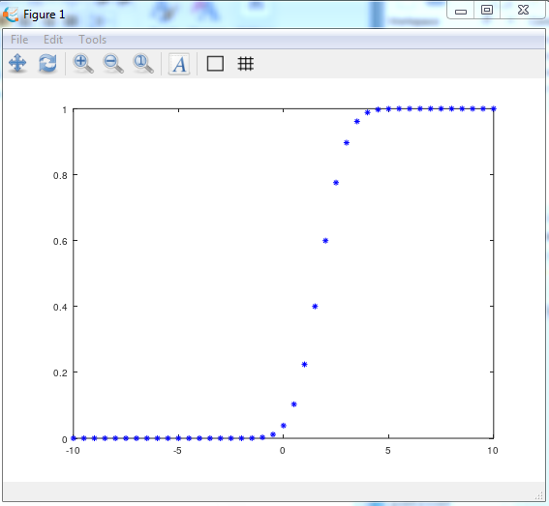variance = fn_variance(pdf, x)

Screenshot:

